This report evaluates the effectiveness of three interventions which is Lifestyle, Met, and Rosi based on their observed success rate and bootstrap analysis. We calculated the average success rate of each treatment. Then, we performed 10,000 bootstrap resamples within each treatment group, preserving each group’s sample size. KDE and ECDF plots summarized the bootstrap distributions of success rates and pairwise ATEs. We calculated 95% percentile bootstrap confidence intervals using the 2.5th and 97.5th percentiles.

Table 1: Summary of each treatment outcome

Treatment | Average Success Rate | Rank
Rosi | 61.4% | 1
Lifestyle | 53.4% | 2
Met | 48.3% | 3

Rosi has the highest average success rate at 61.4%, followed by Lifestyle at 53.4% and Met at 48.3%. This is further supported by the KDE and ECDF plots by showing that Rosi’s distribution shifted furthest to the right.
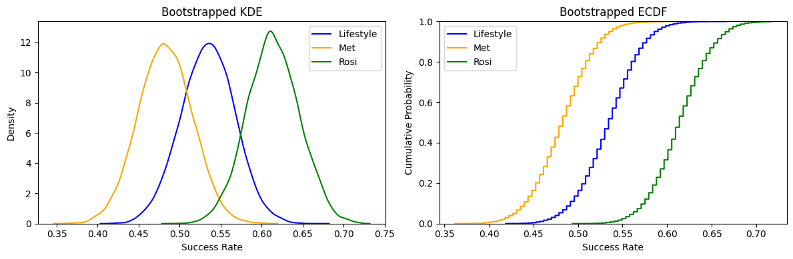

Table 2: Bootstrap confidence intervals for treatment difference

Comparison | 95% confidence interval | Statistically significant?
Met vs Rosi | [-0.221, -0.041] | Yes
Met vs Lifestyle | [-0.141, 0.039] | No
Rosi vs Lifestyle | [-0.010, 0.169] | No

The 95% bootstrap confidence interval showed a statistically significant difference between Met and Rosi because it excludes zero. This means that Rosi has a higher success rate than Met at 5% significant level. However, the confidence intervals for Met vs Lifestyle and Rosi vs Lifestyle include zero, indicating statistically insignificant in effectiveness.

Based on these findings, we suggest considering Rosi over Met because it has the highest observed success rate at 61.4% and a statistically significantly higher success rate than Met. However, there is insufficient evidence to conclude that Rosi is more effective than Lifestyle. Since the difference between Met and Lifestyle is also not statistically significant, we cannot determine which is the better alternative. Further research with a larger sample size may help distinguish the differences between treatments more clearly.

